**Requirement Analysis for Hotel Management System**

In 21st century all the manual processes are leveling-up to the online process. Similarly the hotel management also need to one through the online source .To do so we need to build a software for hotel management .

The problems that have been occurred due to current manual system will be managed with the help of Hotel Management System which will be produced by project team. It has attractive interfaces which provided the friendly functions. It provides the easy access to the system.

**Requirements for hotel management:**

* Make Reservation
* Search Rooms
* Add Payment
* Issue Bills
* Manage the Guest (Add, Update Guest)
* Manage Room Details (Add, Update, Delete)
* Manage the Staff (Add, Update, Delete, View)
* Manage Inventory (Add, Edit, Delete)
* Set Rates
* Retrieve Reports (Stall Payment, Income)
* Manage Users (Add, Update, Delete)
* Tacking Backups
* Email Notifications

**Risk Assessment:**

**1.** Security Risks:

Hotel management software can help to identify security risks and vulnerabilities in the hotel, such as unauthorized access to restricted areas, theft, or fraud. The software can be used to monitor security cameras, control access to different parts of the hotel, and track any suspicious activity.

2. Financial Risks:

Hotel management software can be used to assess financial risks, such as fraud, embezzlement, or other financial irregularities. The software can be used to monitor financial transactions, track expenses, and generate reports that highlight any suspicious activities.

**Risk Mitigation :**

1. One of the most important measures to mitigate security risks is to regularly update the hotel management software. This includes installing patches, hotfixes, and other updates to address vulnerabilities and security issues that have been identified

2. One of the most important ways to mitigate financial risk is to ensure that the software has strong security measures in place. This can include things like encryption, multi-factor authentication, and regular security audits to identify and address vulnerabilities.

**Configure JIRA for managing the project to solve the identified problem.**

STEP 1: Click on the project button – Your created projects will be displayed.

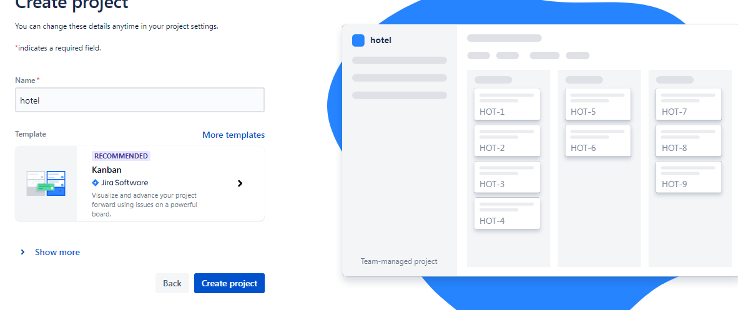

STEP 2: create an issue .

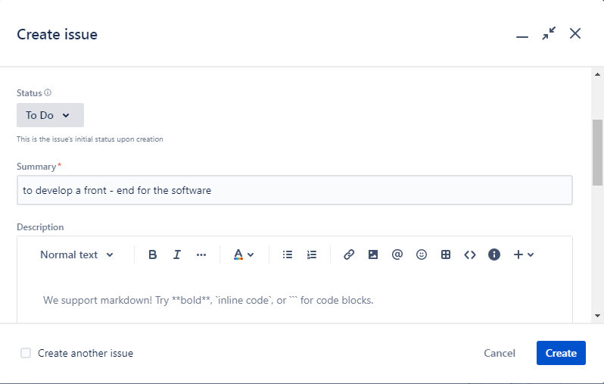

STEP 3: Click on Board and drag the issues to its respective fields.

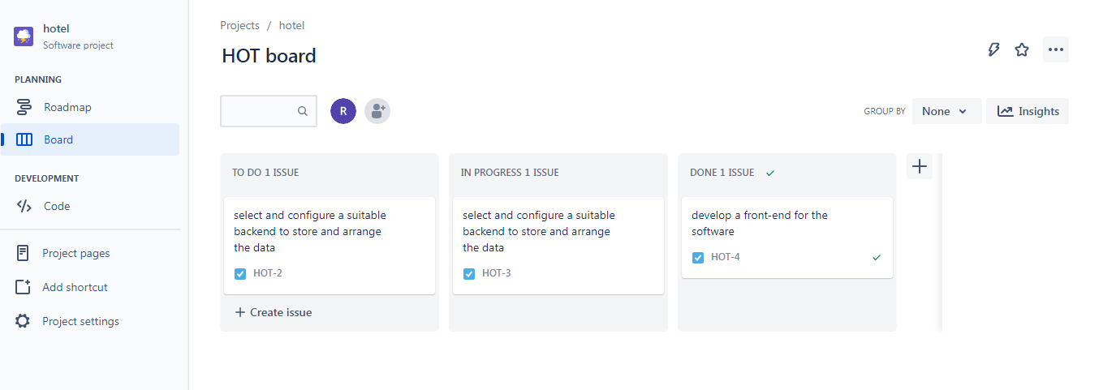

STEP 4: Click on Roadmap and create the Epic and child processes.

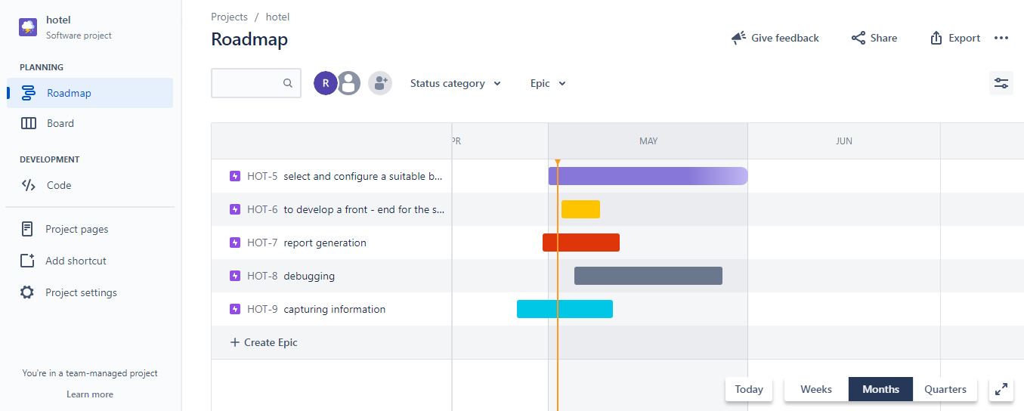

STEP 5: Share the Project to the users.

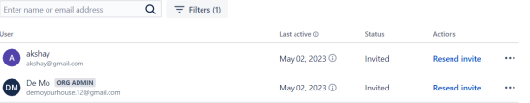

**UML Diagram for Hotel Management System Software**

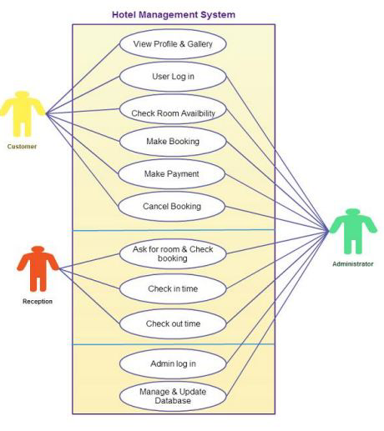

**User stories on Hotel Management System**

| **TITLE:** Customer details | **Priority:** High | **Estimate:**2 |
| --- | --- | --- |
| **User story :** Receptionist  As a Receptionist  I want to add customer information to the system  So that I can create a billing account for patient | | |
| **Acceptance Criteria :**  Given that I can create a billing account for the customer,  When the customer is been first registered ,  So that the records can be maintained | | |

| **TITLE:** Customer | **Priority:** High | **Estimate:**2 |
| --- | --- | --- |
| **User story :** customer  As a Customer  I want to stay and enjoy the facilities provided by hotel  So that I can satisfy my needs. | | |
| **Acceptance Criteria :**  Given that the customer can access all facilities of hotel,  When the customer has booked room ,  So that the customer can fulfill his requirements. | | |

| **TITLE:** Security | **Priority:** High | **Estimate:**2 |
| --- | --- | --- |
| **User story :**IT - Administrator  As a IT - Administrator  I want to ensure data security and privacy  So that I can protect customer information from unauthorized access | | |
| **Acceptance Criteria :**  Given that the IT Administrator want to ensure data security and privacy ,  When there is any unauthorized access,  So that the records can be safe. | | |

| **TITLE:** Financial | **Priority:** High | **Estimate:**2 |
| --- | --- | --- |
| **User story :**Financial Analyst  As a Financial Analyst  I want to analyze billing data to identify trends and opportunities  So that I can provide insights to help the practice optimize revenue and reduce costs | | |
| **Acceptance Criteria :**  Given that the Financial Analyst want to analyze billing data to identify trends and opportunities,  So that he can provide insights to help the practice optimize revenue and reduce costs | | |

| **TITLE:** Staff | **Priority:** very High | **Estimate:**2 |
| --- | --- | --- |
| **User story :** Staff  As a staff member  I want to serve the customer  So that the customer is satisfied. | | |
| **Acceptance Criteria :**  Given that the staff serves the customer,  When the customer has booked room/ordered something,  So that the staff can fulfill his requirements customer. | | |

**Creating a test Plan for the project**

Step1 : install Zephyr scale-test management for jira

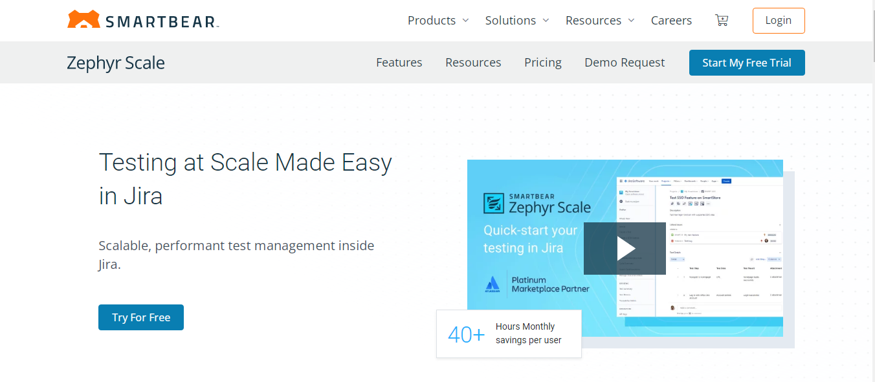

Step2: create test suite for your project.

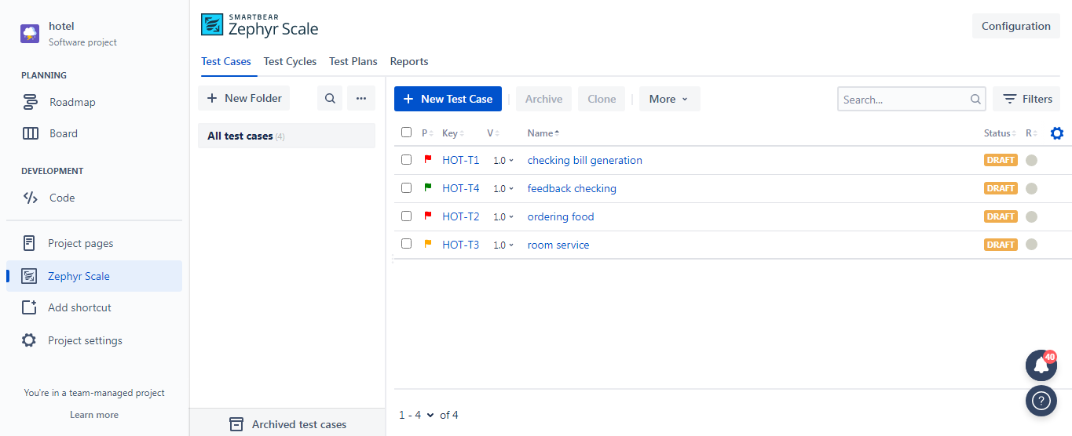

Step3: add details for your test suite(case).

